Modelling for Effective Water Management Strategies
Based on Transportation and Inventory Models

Chen Wei
(2010’, Department of Financial Engineering, School of Management and Engineering,
Nanjing University, Nanjing 210023)
Liu Wei-zhi
(2010’, Department of Industrial Engineering, School of Management and Engineering,
Nanjing University, Nanjing 210023)
Yang Cen-ying
(2009’, Department of Human Resource Management, School of Business,
Nanjing University, Nanjing 210093)

Abstract: We attributed water scarcity to uneven distribution in space and time and solved the former by channeling water across regions and the latter by storing water for future use. We first used a grey model to predict gap between water demand and supply in 2025. Based on our prediction, we then developed two models, namely a transportation model and an inventory model, to address water transfer and storage, respectively. The transportation model was applied to determine a detailed optimal transfer strategy and a news-vendor inventory model was used to determine the optimal amount of water needed for a reservoir. Finally, we provide a comprehensive strategy for the government to make decisions and propose specific measures for four representative regions. Our models are conceptual and solutions are based on mathematical optimization. With more precise data, we will be able to modify our results without much burdensome repetitions.

Key words: water shortage; grey model; transportation model; inventory model;

§1. Introduction
Recent changes in population and geography, from urbanization to climate change, have increased the demand for water and, at the same time, degraded water supplies. The issue is even more severe in China. The Dow’s report (2011) ^{[1]} pointed out that among 661 cities in China, 33% are short of water, and 17% are regarded as badly in lack of water. Feeding the world's 20% population with the world's 6% total water resources poses a great challenge for China, which is now plagued by uneven distribution of water in space and time. Home to 40% of the population of China, northern regions hold only 5% of the nation’s water resources. Over-withdrawals of surface water and groundwater has led to depletion of water resources and environmental damage in some regions (Oelkers et al., 2011) ^{[2]}, further exacerbating the issue. It is about time to take actions to deal with the problem of water shortage, reflected both in quantity and quality.

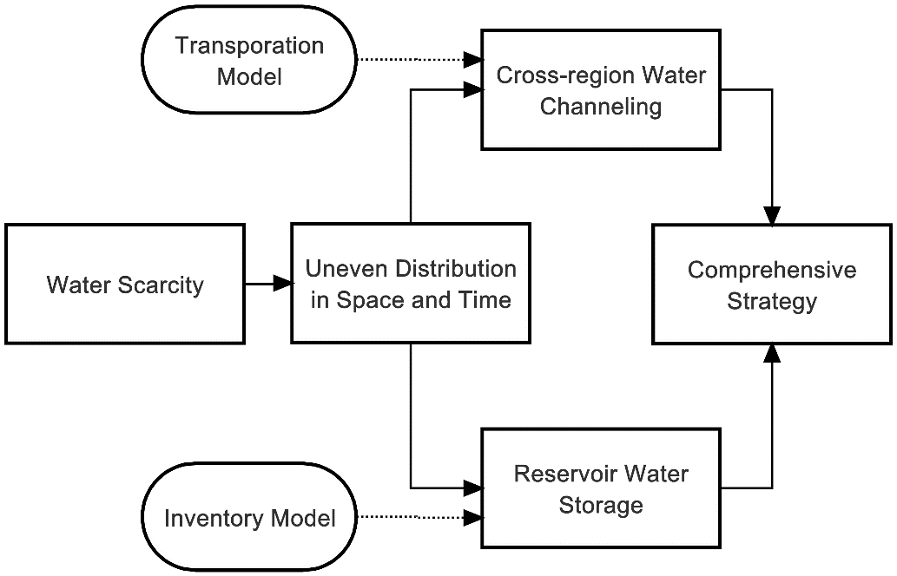
FIG 1: Basic Logic and Framework of the Models

The purpose of the paper is to come up with water strategies to meet the challenge of sustainable water management in China. We regard the problem as uneven water distribution in time and space and consider two strategies: transfer and storage using a transportation model and an inventory model (see Fig. 1). We synthesize the strategies from the perspective of the decision makers in China thereafter. In particular, we answer the following questions:
1. What is the estimated water demand and available water supply in 2025? The answer will lead us to the gaps between water demand and supply across China. Based on the results, we can further analyze the problem.
2. How to solve the predicted issue of water shortage? Based on the logic of our framework, we will come up with two models tackling with water shortage in two separate way, and then a comprehensive model will be used from the perspective of the decision makers of China.
For the rest of our paper, we take every province in mainland China, as well as big municipalities like Beijing, into consideration. For simplicity, we will refer to all of them as "provinces", and there are 30 provinces in our case. Hainan province, Hong Kong SAR, Macao SAR and Taiwan district are omitted since they are more isolated to water management system of mainland China.

§2. Prediction of Water Demand and Supply
Many methods can be used to predict such time series data as water demand and supply, including auto regression, moving average, Box-Jenkins models, grey models, neural network and so forth. Superior to the conventional statistical models, the grey model only requires a relatively small amount of data to estimate the behavior of unknown systems (Deng, 1989; Zhang and Liu, 2001) ^{[3] [4]}. Therefore, considering the limitedness of data available in China, we use a grey model to predict water demand and supply.

§2.1 Data Description
The original province level data are adapted from 1999 to 2011 by National Bureau of Statistics of China ^{[5]}.
We use water usage (in 100 million ) as a proxy for water demand, which includes agricultural, industrial, urban consumption and ecological protection. Note that data for year 2004 data are unavailable due to unknown reasons and for consistency, we take the average demand of 2003 and 2005 to substitute for that of 2004.
We use 40% of total water resource (in million ) as a proxy for water supply. The total amount of water resource is the sum of surface water resources and groundwater resources less the overlap between the two. There are various hierarchies for the quality of natural water resources, a small portion of which is fresh water, and an even smaller portion of fresh water is available for us ^{[1]}. Based on the statistics done by National Bureau of Statistics of China, we take a value of 40% as the average portion of natural water resources available for usage ^{[5]}.

§2.2 The Grey Model
We use the GM(1,1) model to predict water demand and supply in 2025. For every province, denote historical water demand and supply by:
where represents water demand or supply in 1999, and represents historical data of water demand or supply in 2011. Under the rule of accumulated generation operation, we get:
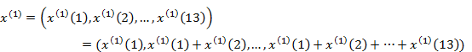
Averaging the sequence, we get a vector with 12 elements:
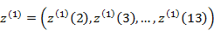
where 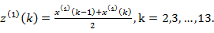 Establishing the grey differential equation:
(1)
yields the albino differential equation for Eq.(1):
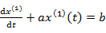 (2)
Solving for Eq.(2) yields:
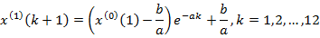
The method is given in the book Application of MATLAB in mathematical Modeling (Zhuo and Wei, 2011) ^{[6]}.
After getting estimated water demand and supply for each province in 2025, we calculate the water gap as:
and use water gaps for our further study.

§2.3 Prediction Results
Fig 2 shows the calculated result. Fifteen provinces will suffer from water shortage in 2025, namely Jiangsu, Xinjiang, Anhui, Shanghai, Henan, Hebei, Heilongjiang, Ningxia, Inner Mongolia, Gansu, Shanxi, Shandong, Hunan, Beijing and Tianjin, most of which are located in northern areas of China. The result aligns with the fact that the issue of water shortage will be more severe in northern China than in southern China, due to fewer precipitation, harsher climate and more demand from agriculture, industry and urban consumption. More specifically, with additional 58.324 billion needed, Jiangsu Province ranks top for water shortage, followed by Xinjiang Province and Anhui Province, with 36.05 billion and 34.93 billion respectively (see Fig. 3).
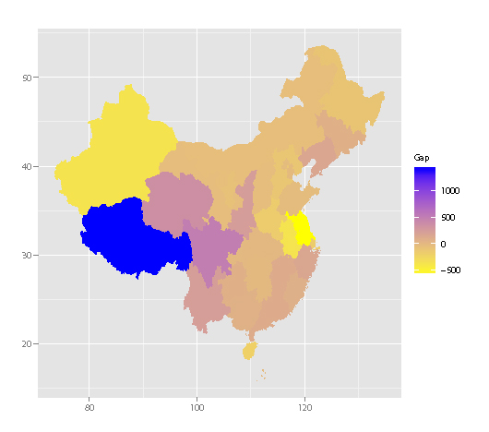
FIG 2: Predicted gaps between water demand and supply across China in 2025
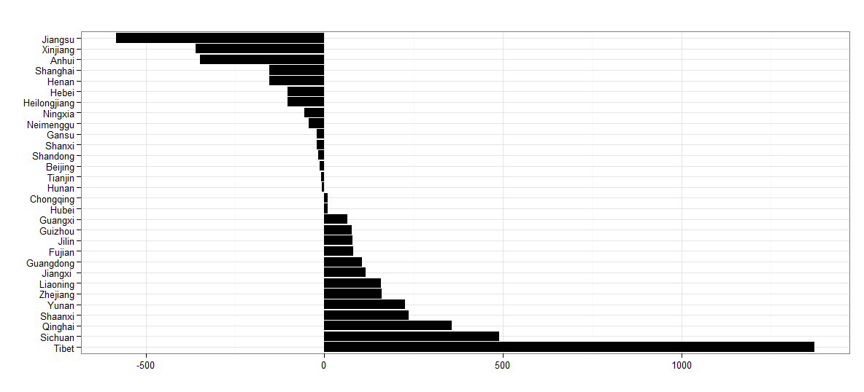
FIG 3: Predicted gaps water between demand and supply across China in 2025

As can be seen in Fig. 2, nearly half of China will be endangered by water shortage in 2025. Based on our prediction, in the following sections we propose two strategies to solve the problem.

§2.4 Sensitivity Analysis
In our assumptions, we mentioned that a portion (40%) of water resources is available for usage. In this part, we try to test the model's sensitivity to changes in this portion. Fig. 4 illustrates results of the analysis. It is suggested by the figure that the change barely affects our predicted water distribution across the country. The value of water gaps, however, changes to some extent with different portions (absolute values of water gaps is shown by the legends in the figure).
One flaw of the grey methods, as well as several models we mentioned before, is that we base the prediction on historical data trends and the assumption that this trend will continue in the future. It is never possible to accurately evaluate whether the assumption holds, so our model is still subject to possible errors. A conceptual model is offered by David et al. (1998) ^{[7]}, which acknowledges the difficulty in quantifying water shortage prediction and base itself on dynamic system of water supply and demand and only requires a set of data in one single year. The authors discuss the precision of the model in their report. However, due to lack of required data, we give up on using their model. When related data are available, we suggest considering their model. More issues of data precision are discussed in the part of strengths and weaknesses of model.
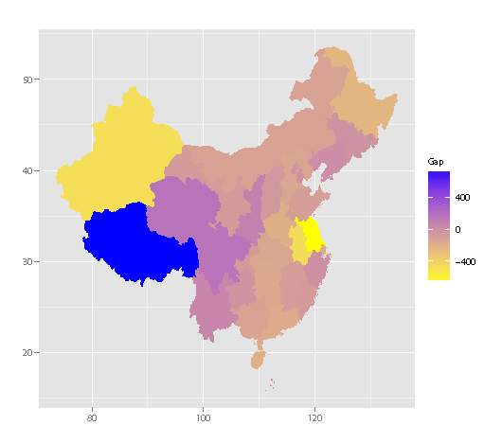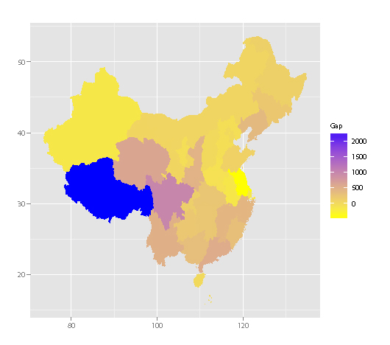
(a) 20% (b) 60%
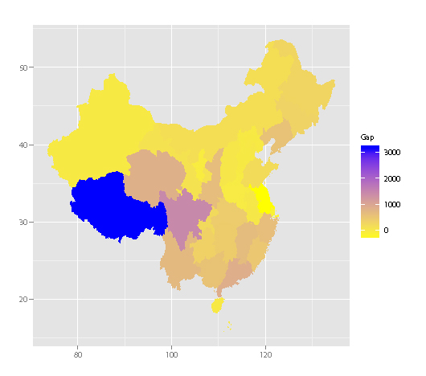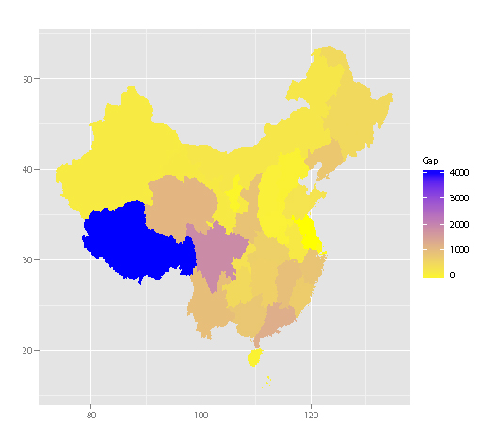
(c) 80% (d) 100%
FIG 4: Predicted Water Distribution on Different Portion of Available Water Supply

§3. Water Channeling
Given the estimated water conditions in 2025, we use a mathematical model to come up with a strategy for water transfer.
There are several major rivers in mainland China, and scholars often partition China into regions around these rivers. These regions are often referred to "river basins". An illustration of this partition is shown in Fig. 5. For simplicity, we refer to river basins as "regions" for the rest of this part.
Since water transportation within a region is relatively easy and costless compared to across regions, we only consider water channeling across regions in our model. That is, we calculate water gap of every region by summing up that of every province belonging to the region.
For every region, we first take its water supply and demand as given, and use a model to determine an optimal transportation strategy satisfying the demand of every region. Based on this model, we then input related data and get the desired strategy.
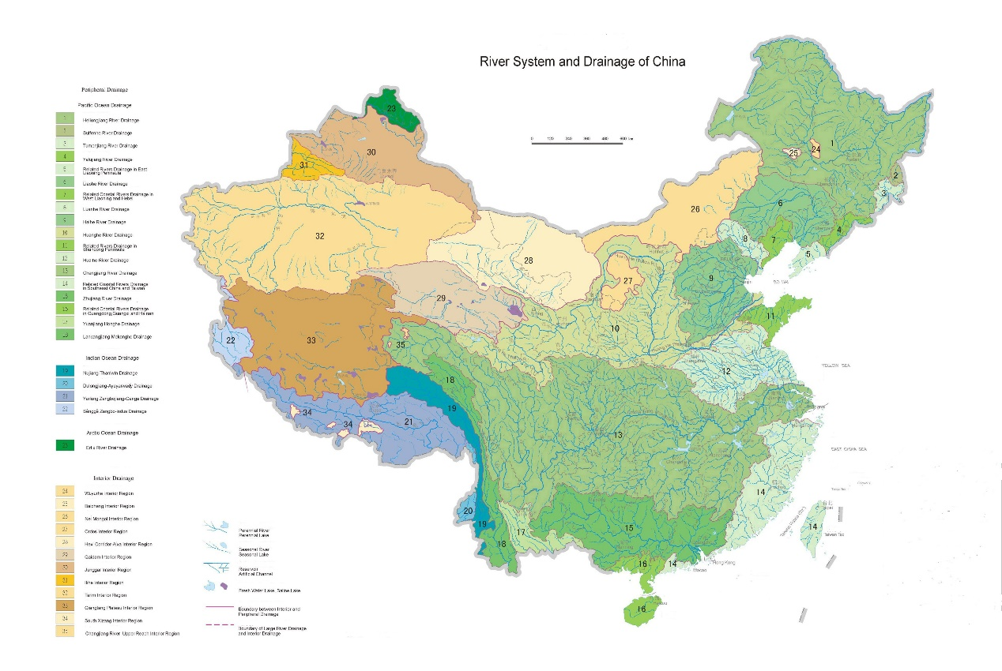
FIG 5: An illustration of river basins in China. Source: Atlas of Natural Disaster System of China (Shi et al., 2003) ^{[8]}

§3.1 Assumptions and Notations
Cost of transportation is proportional to the volume and the distance of water transported. That is, the more and the longer distance water is transported, the more it costs for the government. It is unrealistic to transport a very small amount of water across regions, so we assume that the volume of water transported is large enough to ignore economies of scale.
Transportation is accomplished at the beginning of a year. We simplify a continuous water channeling process into an event accomplished at the beginning of a year. After transportation, water demands in the country are met to the largest extent.
There exists a water transportation channel (or other water transfer projects) between every pair of regions. There are several cross-regional water channeling projects built in China. A famous example is the South-North Water Transfer Project. We assume that under the help of these water transfer projects we are able to transport water between regions.
Notations used in the model are listed as follows:

Table 1: Notations Used in the Transportation Model
Notation | Explanation
 | Region i. There are at total M regions involved.
 | Water supply of region i at the beginning of a year.
 | Water demand of region i for the year.
 | Water gap of region i.
 | Cost of transportation for per unit of water from region i to region j.
E | The set of net water suppliers, i.e., regions with water excess.
S | The set of net water demanders, i.e., regions with water shortage.
m | Number of elements in E, i.e., number of net water suppliers.
n | Number of elements in S, i.e., number of net water demanders.
 | The volume of water transported from region i to region j.
C | Total cost of water transportation.

§3.2 The Transportation Model
We first decide upon the set of regions with water excess or shortage by checking their gaps 's. We let if and let if . For legibility, we rename a positive gap from to and negative ones from to . We discuss below different cases corresponding to different values of total gap .
In the case of G=0, total water excess equals to total water shortage. The optimization problem can be listed as follows:
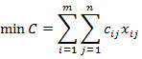
s.t.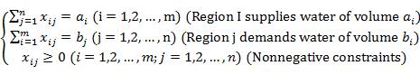
In the case of G>0, total water supply exceeds total water demand. Therefore, everything else being equal, the first constraint changes to:
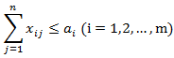
In the case of G<0, total water demand cannot be satisfied by water supplies inside the country. Therefore the second constraint changes to:
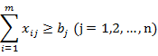

§3.3 Solution
§3.3.1 Parameter Estimation
Regions. As is shown in Fig. 6, we use one of the mainstream partitions which divides mainland China into 7 major regions. We specify them in the Tab. 2 below.

Table 2: Classification of Provinces
Notation | River Basin | Provinces
 | The Southeast River Basin | Fujian, Zhejiang
 | The Haihe River Basin | Beijing, Hebei, Tianjin
 | The Yellow River River Basin | Gansu, Henan, Inner Mongolia, Ningxia, Shaanxi, Shandong, Shanxi
 | The Songliao River Basin | Heilongjiang, Jilin, Liaoning
 | The Southwest River Basin | Tibet, Xinjiang, Yunnan
 | The Long River River Basin | Anhui, Chongqing, Guizhou, Hubei, Hunan, Jiangxi, Jiangsu, Qinghai, Shanghai, Sichuan
 | The Perl River River Basin | Guangdong, Guangxi

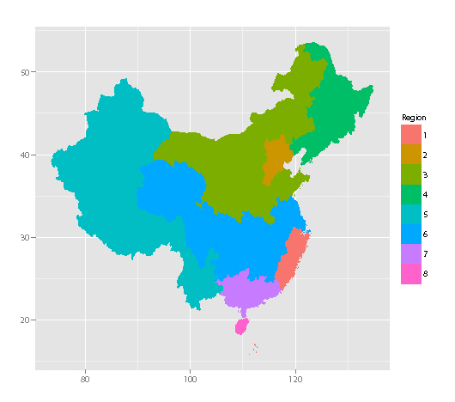
FIG 6: The 7 Regions We Use in the Model (Note that the region in the graph is Hainan Province, which we ignore in our model.)

Supplies and demands. We get from section §2.3 the projected water condition in 2025. According to our estimation, two regions will face water shortage, namely
(12.32 billion ) and (5.21 billion ), and the rest 5 regions have water surplus (26.18 billion for , 15.90 billion for , 128.68 billion for , 53.37 billion for , 19.70 billion ). Total water gap in China will sum up to G=179.27 billion . The predicted net supplies and demands are also available, using the data above. In this case, we have E={, , , , }, and S={, }.
Cost of transportation per per km. We first determine the distances between regions. Since shapes of regions are irregular, there is no way to accurately capture the intrinsic distances, which leaves us to estimate such values. We take mean distance between provinces of each region as a measurement of region distances. To approximate this measurement, we choose a central city in each region and take the distance between these cities. We take cities Wenzhou, Beijing, Yan'an, Changchun, Lasa, Chongqing and Foshan to represent the center of from to , respectively (see Fig. 7). The distances calculated are listed below in Tab. 2. For example, the element in the first row and the first column stands for the distance between and . For simplicity, we arbitrarily assume that transporting water 1 km costs 0.1 yuan, then the unit cost equals to 10% of the distance between regions involved.
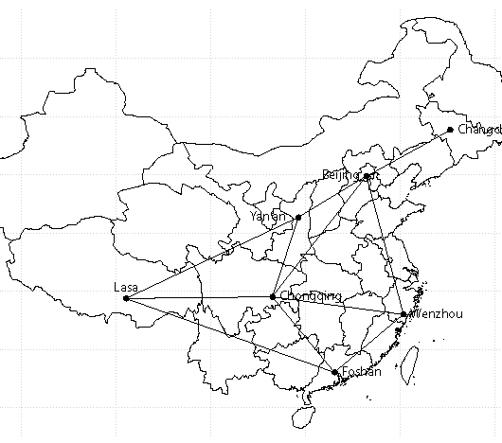
FIG 7: Cities Standing for Centers for Regions and an Illustration of Water Channeling Network

Table 3: Distance Matrix for Regions
Distance (in km)
 | 1382
 | 1420 | 710
 | 1809 | 858 | 1564
 | 2880 | 2564 | 1872 | 3400
 | 1390 | 1460 | 828 | 2300 | 1490
 | 940 | 1904 | 1550 | 2570 | 2310 | 980
The problem is a linear programming problem, or more, a typical transportation model. With costs, supplies and demands available, we specify the model and solve for the problem. The result is shown in Tab. 4.

§3.3.2 Conclusion of Results
Based on the solution given by solving for the problem, we have a water channeling strategy to deal with water shortage in the year of 2025:
Transport 12.32 billion water from (The Songliao River Basin) to (The Hehai River Basin), which costs 1057.30 billion yuan;
Transport 5.21 billion water from (The Long River River Basin) to (The Yellow River River Basin), which costs 431.46 billion yuan.
The total cost sums up to 14.88 billion yuan.

Table 4: Water Channeling Strategy
From | To | Volume | Cost
 |  | 12.32 | 1057.30
 |  | 5.21 | 431.46
 |  | Total Cost (C) | 1488.76

§3.4 Sensitivity Analysis
The model uses a lot of estimated data as parameters, in addition to the estimated water gaps given by the prediction model. Therefore, we should carefully examine the model's sensitivity to changes in estimated results. Using the data given above as a basis, we look into the effect of partial changes of data. From Tab. 5 we see that the total cost does not change more than estimation. But still, our model is to some extent reliant on the values of estimations. However, the optimality of our result is not negated by this sensitivity, since the model yields an analytic optimal result. In other words, our model always produces the best transportation path given that the related data are correct.

Table 5: Sensitivity Analysis of the Transportation Model
Changes in distance between and | Change in total cost
20.00% | 14.20%
10.00% | 7.10%
-10.00% | -7.10%
-20.00% | -14.20%

§4. Water Storage
Unlike water channeling, water storage is mainly used to deal with uneven water distribution in time, where water is stored for later use. Methods range from natural water stores, such as groundwater aquifers, to reservoirs behind major dams. In this section, we examine how reservoirs can be best used to resolve the future shortage.
Determining the volume of water needed for later use is similar to an inventory problem, which looks to solve for an optimal order quantity at a certain time point to satisfy the stochastic demands in the future. Therefore, we apply a classic news-vendor inventory model to solve the problem. For the convenience of modeling and consistency with jargon commonly used, we use the word "demand" as water gaps derived above.
For the rest of this section, we build up a theoretical inventory model and then study the case of the Three Gorges Reservoir in China for application of our model.

§4.1 Assumptions and Notations
Reservoirs store water from both its upstream and precipitation. There are two main water sources for reservoirs. The order quantity from its upstream should exclude precipitation;
Reservoirs store water to satisfy local and downstream demands. It is impossible or too expensive for reservoirs to transport water to the areas upstream. The amount needed equals to demand less normal storage, which is the existing storage in the reservoir;
We allow stock-out costs and holding costs to occur. In the former case, areas in the downstream suffer from water shortage, thus incurring economic loss. In the latter case, excess water lead to opportunity cost lost by upstream areas;
Downstream demands are normally distributed, whose cumulative distribution function is F(x) and probability density function is f(x).
Notations used in the model are listed as follows:

Table 6: Notations Used in the Transportation Model
Notation | Explanation
 | Downstream demand, which is stochastic.
 | Order quantity by reservoir.
s | Stock-out cost, reflected by the economic loss in the downstream when gaps cannot be met.
c | Holding cost, reflected by the opportunity cost lost in the upstream when order quantity exceed gaps.
TC | Total cost for the whole system.

§4.2 The News-vendor Inventory Model
We aim to determine the optimal order quantity to minimize the total cost. So the target function can be written as follows:
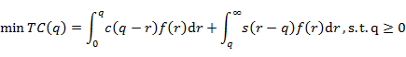
To solve the problem, we set the first order derivative of TC(q) equal to zero and get:
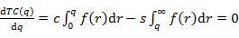 (3)
Since the second order derivative of TC(q) is nonnegative:
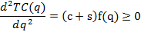
the optimal solution exists for the problem. Solving the Eq. (3), we get the optimal order quantity when:
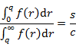

§4.3 Case Study: the Three Gorges Reservoir
We apply theoretical model to the Three Gorges Reservoir, which is the largest reservoir in China. Located in Yichang city and spanning the Yangtze River, the reservoir is the main water supplier to its downstream areas, including Jiangsu, Anhui, Shanghai and Hunan. Both the representativeness and the strategic significance lead us to use the Three Gorges Reservoir as a case to study.

§4.3.1 Normality Test for Historical Demands
We take historical data of total water demands of provinces around the downstream of the Three Gorges Reservoir to test our assumption of their normality. A Q-Q plot of data (see Fig. 8) suggests that they behave quite well in terms of normality. A Shapiro-Wilk test also confirms our hypothesis (W = 0.9885, p = 0.5429), which means that under the hypothesis of normality of sample data, the possibility of getting a W statistic more extreme than or as extreme as the observed one (W = 0.9885) is 54.29%. Therefore, our data supports the hypothesis and we accept the normality assumption.
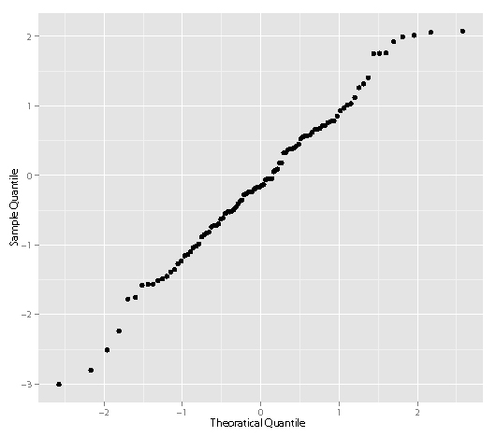
FIG 8: The Q-Q Plot for Historical Data

§4.3.2 Parameter Estimation
We define the stock-out cost as the economic loss suffered by downstream areas due to inadequate water supply, since water shortage has a direct negative impact on agricultural production, industrial output and urban consumption, further influencing the local GDP. Water consumption per 10 thousand yuan of GDP is an official method to measure the contribution of water to the total GDP. So we use the GDP each of water can generate to quantify the stock-out cost.
We define holding cost as the opportunity cost, in which case upstream areas can use excess water for other uses, such as agricultural production, industrial output and urban consumption. Accordingly, we also use the GDP each of water can generate to quantify the holding cost. We ignore negative environmental effects for simplicity.
As for the Three Gorges Reservoir, its downstream areas include Hubei Province, Hunan Province, Jiangxi Province, Anhui Province and Shanghai and its upstream areas include Qinghai Province, Sichuan Province, Guizhou Province and Chongqing. Stock-out cost of each province is calculated by local GDP divided by water consumption, and the total stock-out cost, denoted by s, is the average of the stock-out cost in its downstream area, and so is the total holding cost, denoted by c. Original data are adapted from National Bureau of Statistics ^{[5]} and through simple computation, we get s=53.44 yuan/ and c=222.43 yuan/.
Taking into account the precipitation and normal storage in the reservoir, which is the minimal requirement of the reservoir, we define net demand as:
where gap is the average of respective provinces in downstream or upstream, which equals to 154.48 billion . Precipitation is calculated by:
where data are adapted from Wikipedia, from which we also get the normal storage equaling to 393 .
So we can get the net demand of 115.16 billion . Since we treat precipitation and normal storage as constants, standard deviation of net demand equals to that of gap, that is, 440 .

§4.3.3 Solutions and Simulation of the Model
With known normal distribution of net demand and parameters of s and c, we can solve for the theoretical results for the news-vendor problem. The optimal order quantity is 84.1 billion (see Fig. 9). We use the Matlab symbolic computational methods to come up with the expected total cost of every possible order quantity. Fig. 10 shows that the best order quantity is 84.1 trillion We randomly generate 500 random water demands of downstream of the Three Georges Dam according to a Gaussian Distribution (mean = 1152, standard deviation = 440) and then compute the total cost given the optimal order quantity 84.1 trillion (see Fig. 11).
Considering 2025 as the next stock period, we suggest that the Three Gorges Reservoir store 84.1 billion water to satisfy the future water gap by downstream areas. The case study also verifies that the news-vendor inventory model is a strong theoretical model to tackle with realistic problems. With more precise data, governments will be able to make wise decision on order quantity by getting more accurate normal distribution of demand, stock-out cost and holding cost.
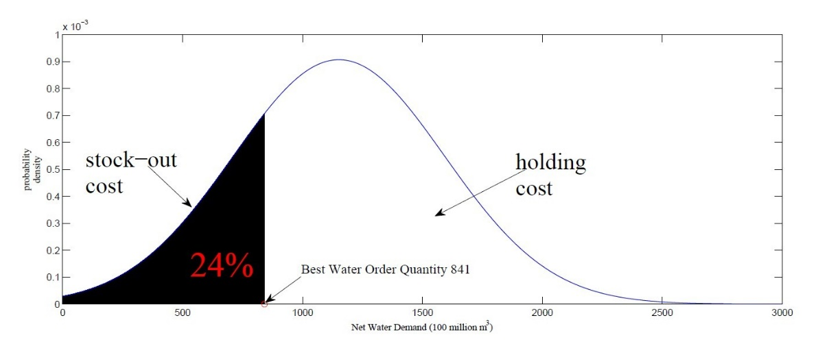
FIG 9: Solution to the News-vendor Inventory Model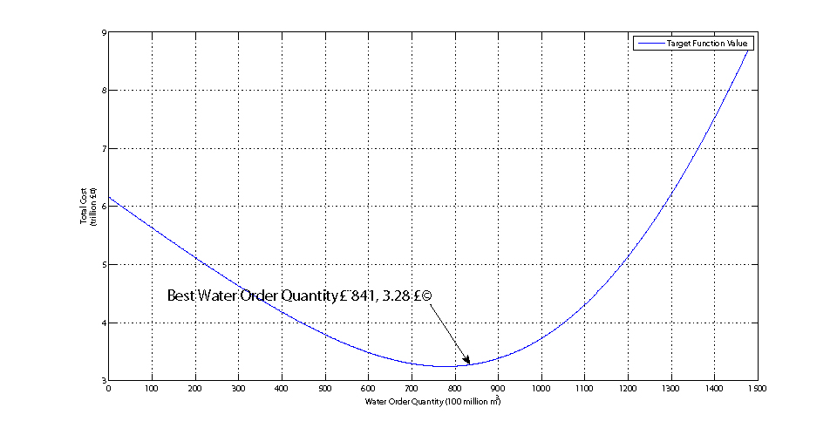
FIG 10: The Target Function

§4.2 Sensitivity Analysis
The minimum expected total cost calculated by our model can help decision makers better deal with future uncertainty. However, environmental or social factors are not considered in the cost: possible cost includes environmental damage and forced migration. Another limitation is that normality of demand's distribution must be strictly met. In our model, we use contributions of water to GDP in downstream and upstream as the estimation of stock-out cost and holding cost. Here, we test the impact of their fluctuation on total cost and order quantity (see Fig. 12).
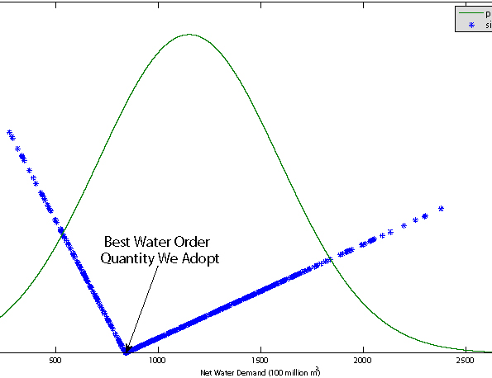
FIG 11: The Monte-Carlo Simulation of Water Demands
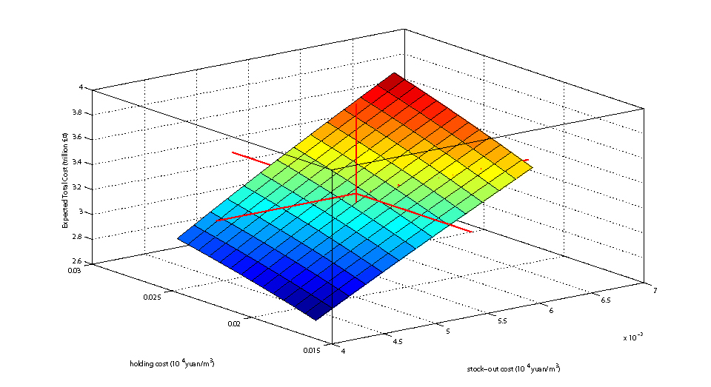
FIG 12: Visualization of Sensitivity Analysis

§5. Conclusions and Discussions
§5.1 Conclusions of the Two Basic Models
With built models, we are now able to answer the questions raised in section §1.
1. What is the estimated water demand and available water supply in 2025? Using a grey model, we predict that 15 provinces will be in short of water in 2025, most of which are located in northern China. Jiangsu province will be most endangered by water shortage, with a gap of 58.32 billion .
2. How to solve the predicted issue of water shortage? Considering spatial distribution, we apply a transportation model to address water channeling. Partitioning the vast country into seven river basins and summing up water gaps of provinces belonging to the region, we find that the Hehai River Basin and Yellow River River Basin will be short of water in 2025. Our transportation model suggests an optimal channeling strategy that the Songliao River Basin transfers water to Hehai River Basin and the Long River River Basin to the Yellow River River Basin, with a total cost of 14.88 billion yuan.

§5.2 Strengths and Weaknesses
As is shown in Tab. 7, for the following we discuss strengths and weakness of our models:
Water channeling is an advantageous strategy in situations of emergency, or uncertain water needs, and is especially useful for dealing with uneven spatial distribution of water resources. However, cross-region water channeling projects are likely to incur a great amount of construction fees and a long duration of construction.
Water storage, on the other hand, is easy to implement in the sense that reservoirs are usually located near large rivers and enjoy easy accesses to water. The location of a reservoir, however, is also its limitation, for it might cause natural disasters to occur, such as earthquake. This strategy works best when downstream demand is relatively stable, that is, in the case where no major unexpected emergency arises.

Table 7: Discussion of the Two Models
 | Water Channeling | Water Storage
Advantages | Satisfy urgent water demand. | Easy to operate.
Disadvantages | High construction costs and long construction terms for cross-region water channeling projects. | - Construction of reservoirs may induce natural disasters like earthquakes;  - Operation costs can be high.
Applicable Conditions | Uncertain water demands. | - Certain water demands from downstream;  - Large reservoir capacity.

One major problem facing us is the precision of data. Data from different resources follow different criteria, thus may present inconsistency overall. Also, although our data come from official sources like the National Bureau of Statistics of China, they are still subject to manipulation for many reasons. Different interpretations of data, on the other hand, leads to different result. On the other hand, data used for parameter estimations, for example, per unit cost of water transportation, are hard to attain or estimate, which will greatly result in significant changes in final strategy should our estimation deviates from the intrinsic value.
However, to obtain the desired data is no easy job. It often require long-term surveys and study, as well as the assistance from expertise in related field. Due to the limitation of our research, there is no way to accurately capture these data. Acknowledging this fact, we manage to build conceptual models with logical reasoning and mathematical calculation (The grey model is an exception. The reason for using a grey model is discussed in section §2.4 and an alternative conceptual model is also offered.), under the assumption that we have the precise data. This way, we are able to modify our final strategies as soon as we obtain more accurate data, say, from the government or other sources, without doing many burdensome repetitions.

§5.3 A Comprehensive Water Strategy
Based on our prediction of future water conditions, we propose 3 specific plans to deal with the problem in 2025 from the perspective of decision makers in China.
The Priority should be given to Jiangsu Province since it will suffer most from water shortage in 2025. Jiangsu is a relatively developed province, so we recommend using the water storage strategy. Many reservoirs are located in Jiangsu, governments can choose to make water storage strategy based on our news-vendor inventory model. Investigation should be careful carried out to estimate parameters precisely, however, to better capture water demands and supplies.
Henan Province is representative of inland area with major agricultural industry, so we recommend the water storage strategy to solve the problem, in that the mainstream of Yellow River flows through the province. Decisions should be carefully made on how much water needed to store for later gap.
For Beijing, Tianjin and Shandong Province, we recommend the water channeling strategy, specifically transporting water from southern areas. The three neighboring provinces can generate great synergy, directly beneficiary of cross-region water channeling projects.

References
- The Dow Chemical Company. (2011) China's Thirst for Water.
- Oelkers, E. H., Hering, J. G., & Zhu, C. (2011) Water: Is There a Global Crisis?. Elements, 7(3), 157-162.
- Deng, J. L. (1989). Introduction to grey system theory. The Journal of grey system, 1(1), 1-24.
- 张雅君，刘全胜. (2001). 需水量预测方法的评析与择优. 中国给水排水, 17(7), 27-29.
- The National Bureau of Statistics of China. (1999-2011) Statistical Yearbook of China.
- 卓金武，魏永生. (2011). Matlab 在数学建模中的应用.
- Seckler, David William. World water demand and supply, 1990 to 2025: Scenarios and issues. Vol. 19. Iwmi, 1998.
- 史培军,，王静爱，杨明川. (2003). 中国自然灾害系统地图集.1999-2011.

基于运输模型和库存模型的有效水资源管理策略的建模

陈炜
(南京大学工程管理学院金融工程系2010级，南京 210023)
刘威志
(南京大学工程管理学院工业工程系2010级，南京 210023)
杨岑莹
（南京大学商学院管理学院人力资源管理系2009级，南京 210093）

摘要： 本文将水资源短缺归因于水资源在时间与空间上的不均匀分布，并提出了以跨流域调水解决前者、以水库蓄水解决后者的策略。首先，我们使用灰色模型预测了2025年中国各省份的水资源供给与需求。基于预测结果，我们分别讨论了运输模型和库存模型在跨流域调水与水库蓄水问题的应用。我们使用了运输模型求解最优水资源调度反感，使用了库存论中的报童模型求解水库最优需水量。最后，我们以政府或管理者的视角提出了综合的水资源管理策略，并针对一些区域提出具体的水资源管理方案。本文提出的模型属于概念模型，即模型求解结果是基于数学计算的最优值。若使用更加准确的数据，我们能够在不作出更多重复工作的情况下提出响应的最优水资源管理策略。
关键字：水资源短缺；灰色模型；运输模型；库存模型

